Rwanda

## Population Data

The data set shows the political stability estimate of the country each year.

## # A tibble: 23 x 5  
## country iso3c date population popCategory5  
## <chr> <chr> <dbl> <dbl> <chr>   
## 1 Rwanda RWA 1996 6013107 small   
## 2 Rwanda RWA 1997 6419901 small   
## 3 Rwanda RWA 1998 6962802 small   
## 4 Rwanda RWA 1999 7501234 small   
## 5 Rwanda RWA 2000 7933681 small   
## 6 Rwanda RWA 2001 8231156 small   
## 7 Rwanda RWA 2002 8427060 small   
## 8 Rwanda RWA 2003 8557161 small   
## 9 Rwanda RWA 2004 8680524 small   
## 10 Rwanda RWA 2005 8840215 small   
## 11 Rwanda RWA 2006 9043337 small   
## 12 Rwanda RWA 2007 9273757 small   
## 13 Rwanda RWA 2008 9524534 small   
## 14 Rwanda RWA 2009 9782770 small   
## 15 Rwanda RWA 2010 10039338 small   
## 16 Rwanda RWA 2011 10293331 small   
## 17 Rwanda RWA 2012 10549678 small   
## 18 Rwanda RWA 2013 10811543 small   
## 19 Rwanda RWA 2014 11083635 small   
## 20 Rwanda RWA 2015 11369071 small   
## 21 Rwanda RWA 2016 11668818 small   
## 22 Rwanda RWA 2017 11980937 small   
## 23 Rwanda RWA 2018 12301939 small

# Population growth data

## # A tibble: 23 x 5  
## country iso3c date popGrowth popGrowthCat5   
## <chr> <chr> <dbl> <dbl> <chr>   
## 1 Rwanda RWA 1996 2.98 high growth rate   
## 2 Rwanda RWA 1997 6.55 high growth rate   
## 3 Rwanda RWA 1998 8.12 high growth rate   
## 4 Rwanda RWA 1999 7.45 high growth rate   
## 5 Rwanda RWA 2000 5.60 high growth rate   
## 6 Rwanda RWA 2001 3.68 high growth rate   
## 7 Rwanda RWA 2002 2.35 moderate growth rate  
## 8 Rwanda RWA 2003 1.53 moderate growth rate  
## 9 Rwanda RWA 2004 1.43 slow growth rate   
## 10 Rwanda RWA 2005 1.82 moderate growth rate  
## 11 Rwanda RWA 2006 2.27 moderate growth rate  
## 12 Rwanda RWA 2007 2.52 high growth rate   
## 13 Rwanda RWA 2008 2.67 high growth rate   
## 14 Rwanda RWA 2009 2.68 high growth rate   
## 15 Rwanda RWA 2010 2.59 high growth rate   
## 16 Rwanda RWA 2011 2.50 moderate growth rate  
## 17 Rwanda RWA 2012 2.46 moderate growth rate  
## 18 Rwanda RWA 2013 2.45 moderate growth rate  
## 19 Rwanda RWA 2014 2.49 moderate growth rate  
## 20 Rwanda RWA 2015 2.54 high growth rate   
## 21 Rwanda RWA 2016 2.60 high growth rate   
## 22 Rwanda RWA 2017 2.64 high growth rate   
## 23 Rwanda RWA 2018 2.64 high growth rate

## Population trend

The plot shows the population trend of the country.

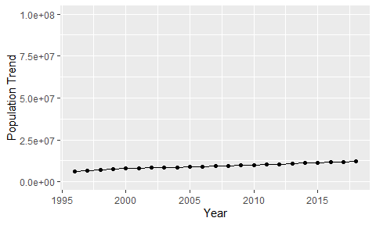

Political Stability Trend

# Population growth trend

The plot shows the population growth rate trend of the country.

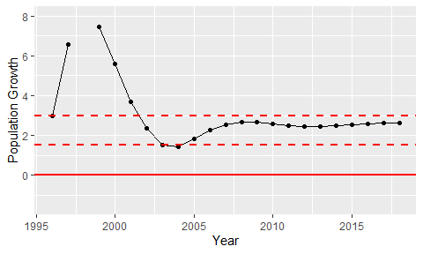

Population Growth Trend